Name: IBRAHIM ALSHAYEA | ID: 202176470 | Section: 53 | Date: 1/25/2024
Task 1 :
Brief explanation:
1 – Initialized a linked list with city names
2 – Search for Dammam in the list. If it is there. Addes tabouk before it.
3 – Add Alkhafj before the last node in the list
4 – display the updated list
output:
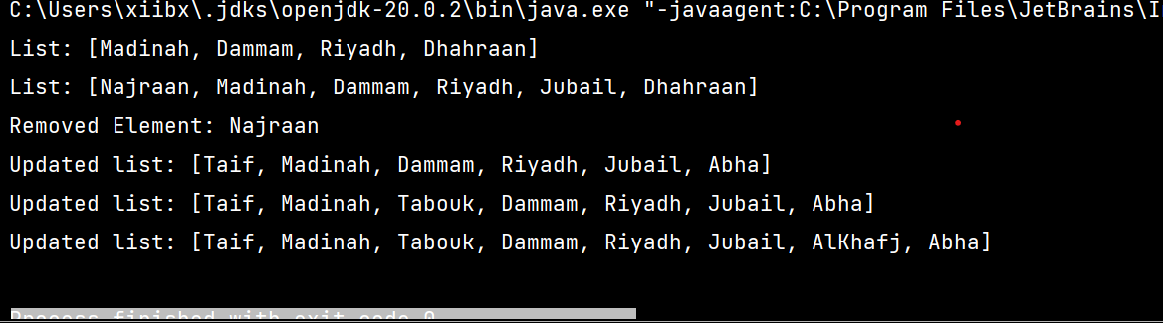

Pert of the code :
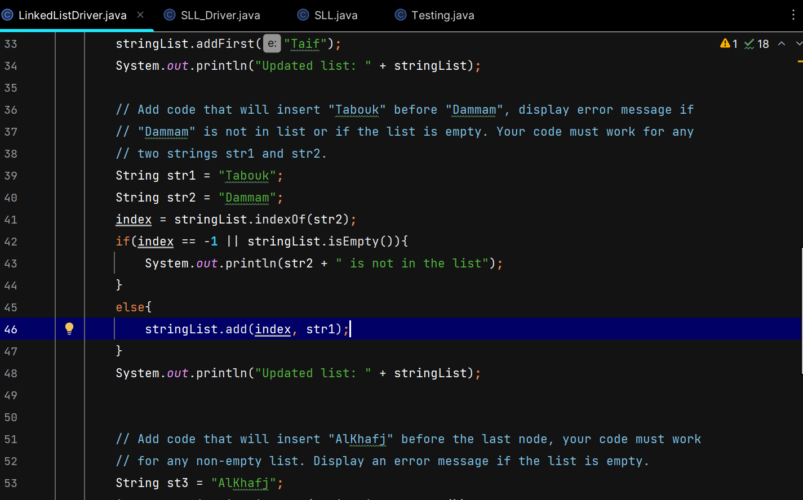
Task 2 :
Brief explanation:
public void insertBefore(int index, T newElem)

This methos insert a new element before a specific index, if the index is negative, out of the list, or the array is empty it throws exception.
public T delete(int index)
This method deletes an element in specified index, if the index is negative, out of the list, or the array is empty it throws exception.
public void insertAfterSecondOccurrence(T e1, T e2) {
This method insert an element after the second occurrence another element, is the other element has no second occurrence or the list is empty, the method will throw an exception.

Part of the code :
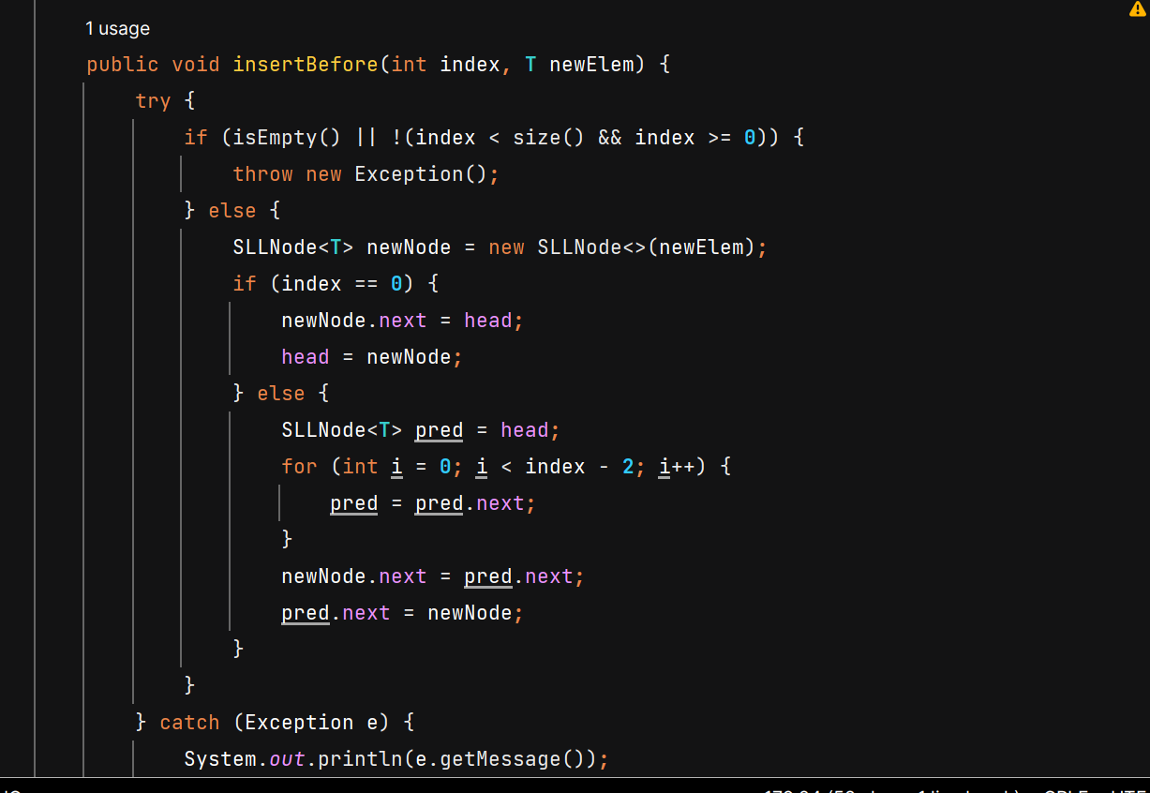

Task 3 :
In this task, I created a class that test the above methods by creating a list of some values and test every method using the list I’ve created.

Part of the code :
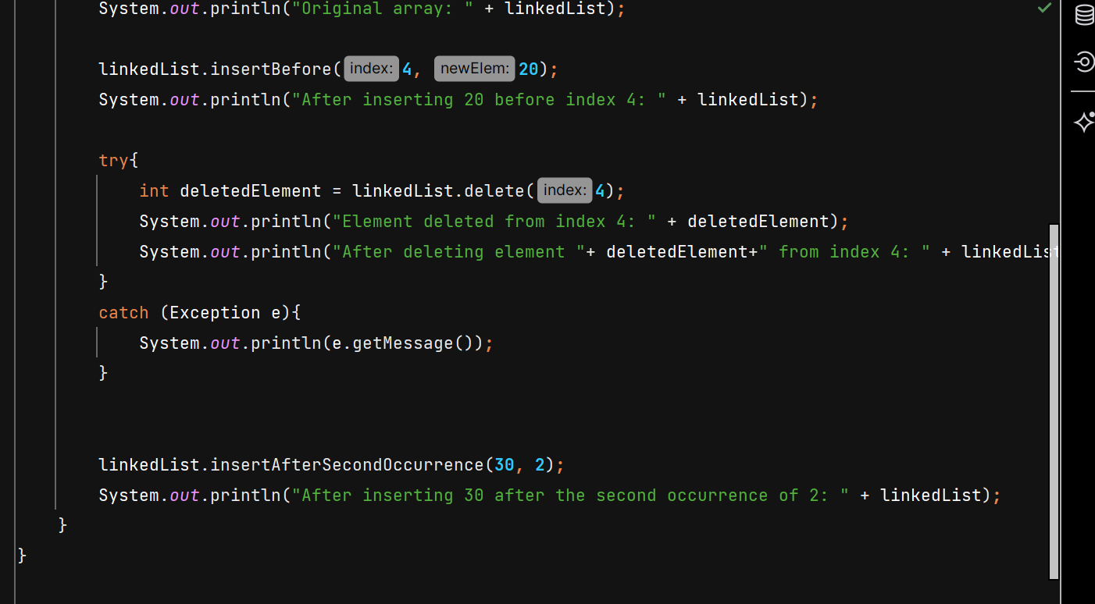

Output :

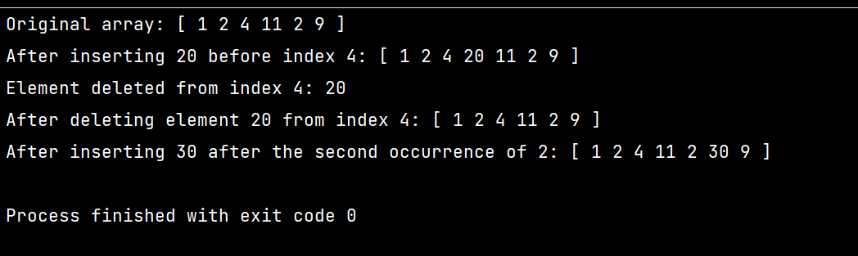

The program is on .java files.

